**[Polar coordinates](https://en.wikipedia.org/wiki/Polar_coordinate_system)** are an alternative way of representing Cartesian coordinates or [Complex Numbers](https://en.wikipedia.org/wiki/Complex_number).

A complex number

is completely determined by its real part  and imaginary part .  
Here,  is the [imaginary unit](https://en.wikipedia.org/wiki/Imaginary_unit).

A polar coordinate () 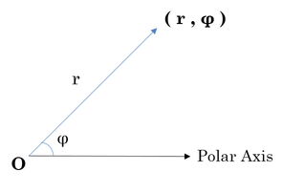

is completely determined by modulus  and phase angle .  
  
If we convert complex number  to its polar coordinate, we find:  
: Distance from  to origin, i.e.,   
: Counter clockwise angle measured from the positive -axis to the line segment that joins  to the origin.

Python's [cmath](https://docs.python.org/2/library/cmath.html) module provides access to the mathematical functions for complex numbers.

This tool returns the phase of complex number  (also known as the argument of ).

>>> phase(complex(-1.0, 0.0))

3.1415926535897931

This tool returns the modulus (absolute value) of complex number .

>>> abs(complex(-1.0, 0.0))

1.0

**Task**  
You are given a complex . Your task is to convert it to polar coordinates.

**Input Format**

A single line containing the complex number . Note: complex() function can be used in python to convert the input as a complex number.

**Constraints**

Given number is a valid complex number

**Output Format**

Output two lines:  
The first line should contain the value of .  
The second line should contain the value of .

**Sample Input**

1+2j

**Sample Output**

2.23606797749979

1.1071487177940904

Note: The output should be correct up to 3 decimal places.